1. **“Activities” page: According to the source page in Wix, there is a line of space between <li>China Journal of Accounting Research (CJAR) Summer Workshop (2010); </li> and <li>University of Indonesia (2023)</li>**
2. **MOST font styles and size are still not consistent with the source pages. You can find such inconsistency everywhere…**

An example:

Wix page:



Github page:



Another example:

Wix page:

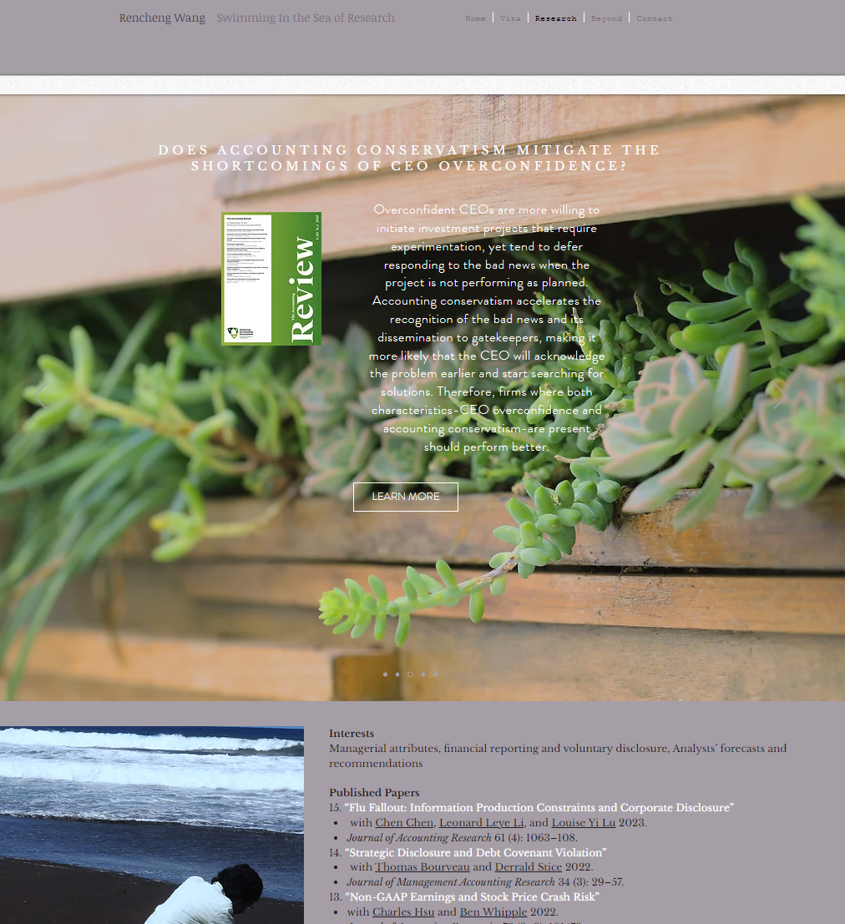

Github page:



1. **Some pics are right in portrait view, but not in landscape view (stretched too much??). It was okay in Wix but not in the github again. This issue is opposite on “beyond” page: the landscape view is fine there, but not for the portrait view. “Home” and “Vita” look all right, but please have a double check on all pages of this issue.**

An example:

Wix: landscape view

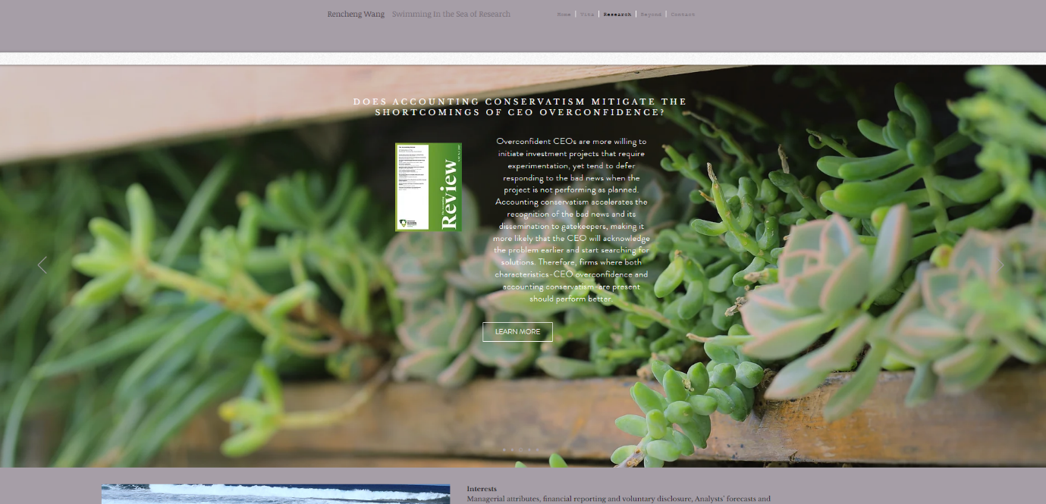

Portrait view

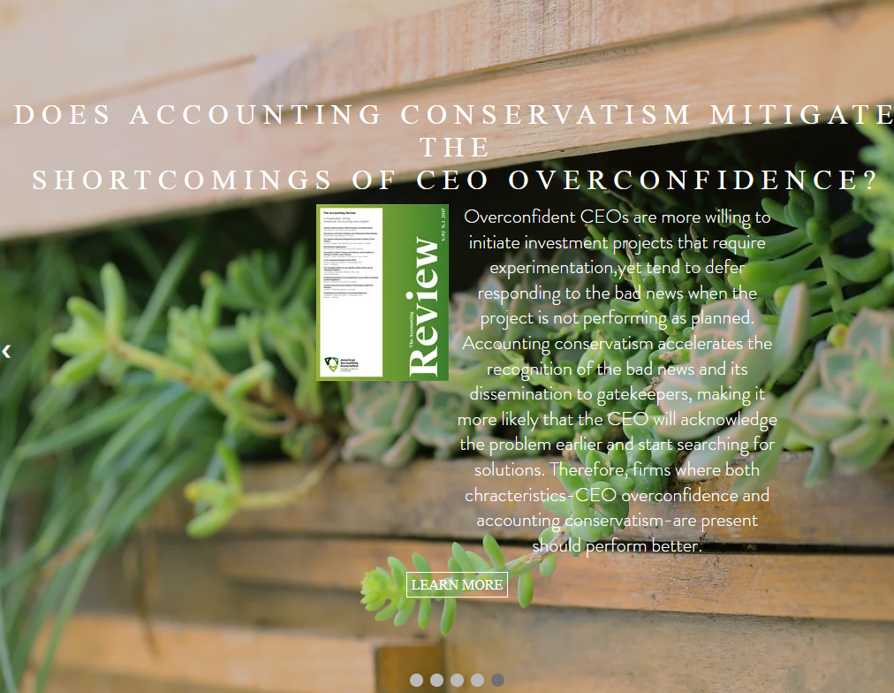

Github: landscape view



Portrait view



1. **“Activities” pictures are not correct in github (see below).**

Wix:



Github:



1. **You use different colors (e.g., green) between pages in github and also they are different from those in wix.**

For example Vita, Activities, Education, Teaching “Vita”’s green is different from others

Another example is the green color used in those picture when the mouse stays. It should be consistent with the colors of Vita, Activities, Education, Teaching too.